Adam Mohmoud
AZ-900 Fundamentals
Microsoft Azure Policy Lab
Mohmoud.adam@gmail.com

In this lab I will create an Azure policy which involves defining and enforcing specific rules and standards for resource configurations in Azure, ensuring compliance, security, and governance across your cloud environment.
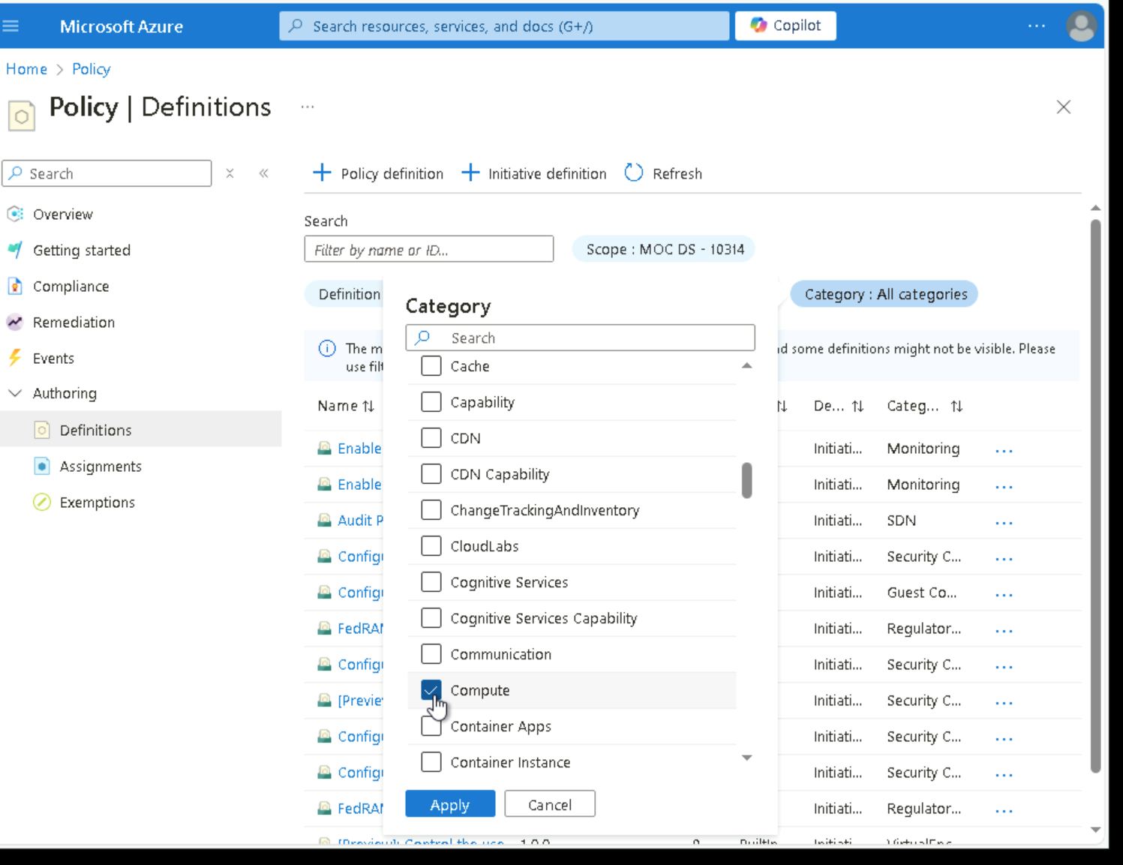

in the Category (1) drop-down, uncheck All checkbox and select only Compute (2) then click Apply (3). Notice the Allowed virtual machine size SKUs definition enables you to specify a set of virtual machine SKUs that your organization can deploy.

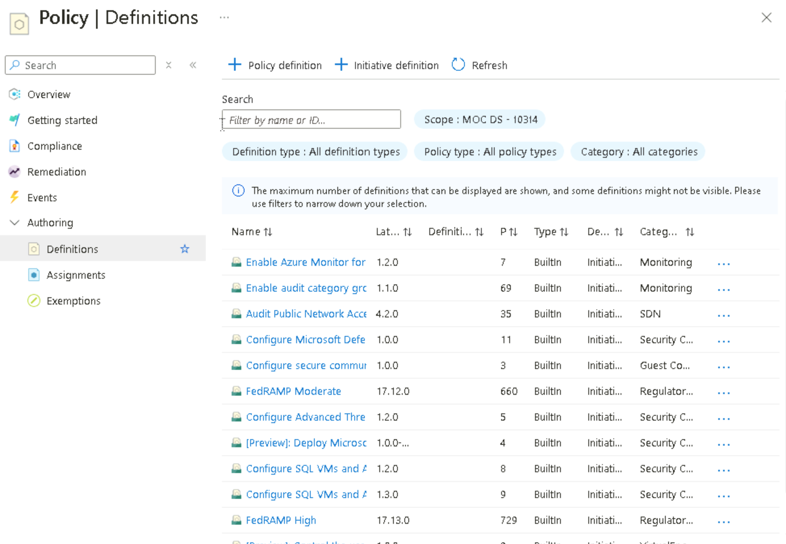
On the Policy page, under the Authoring section click Assignments (1) > Assign Policy (2). An assignment is a policy that has been assigned to take place within a specific scope. For example, a definition could be assigned to the subscription scope.
A scope determines what resources or grouping of resources the policy assignment applies to. In our case we could assign this policy to a specific resource group, however, we chose to assign the policy at the subscription level. Be aware that resources can be excluded based on the scope configuration. Exclusions are optional.

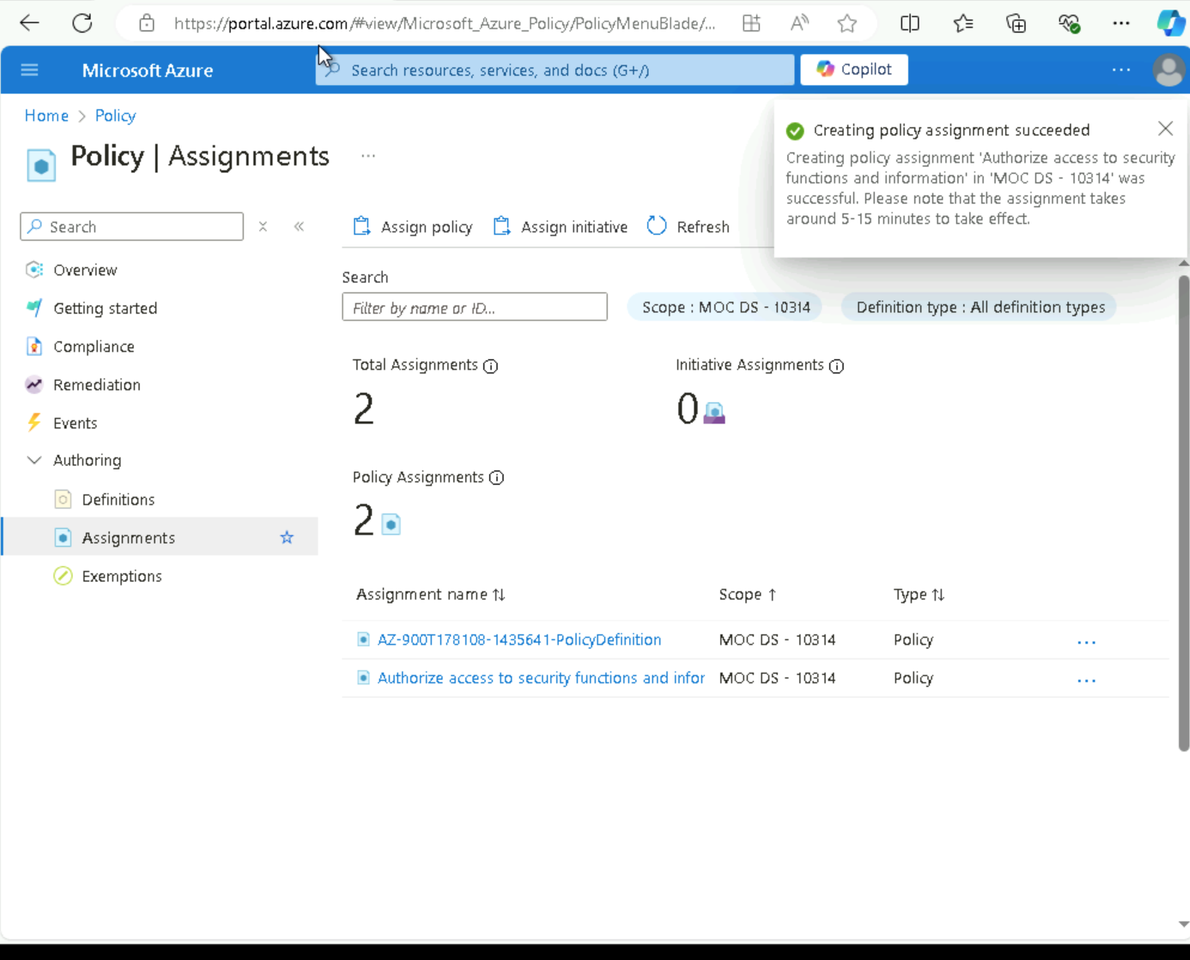
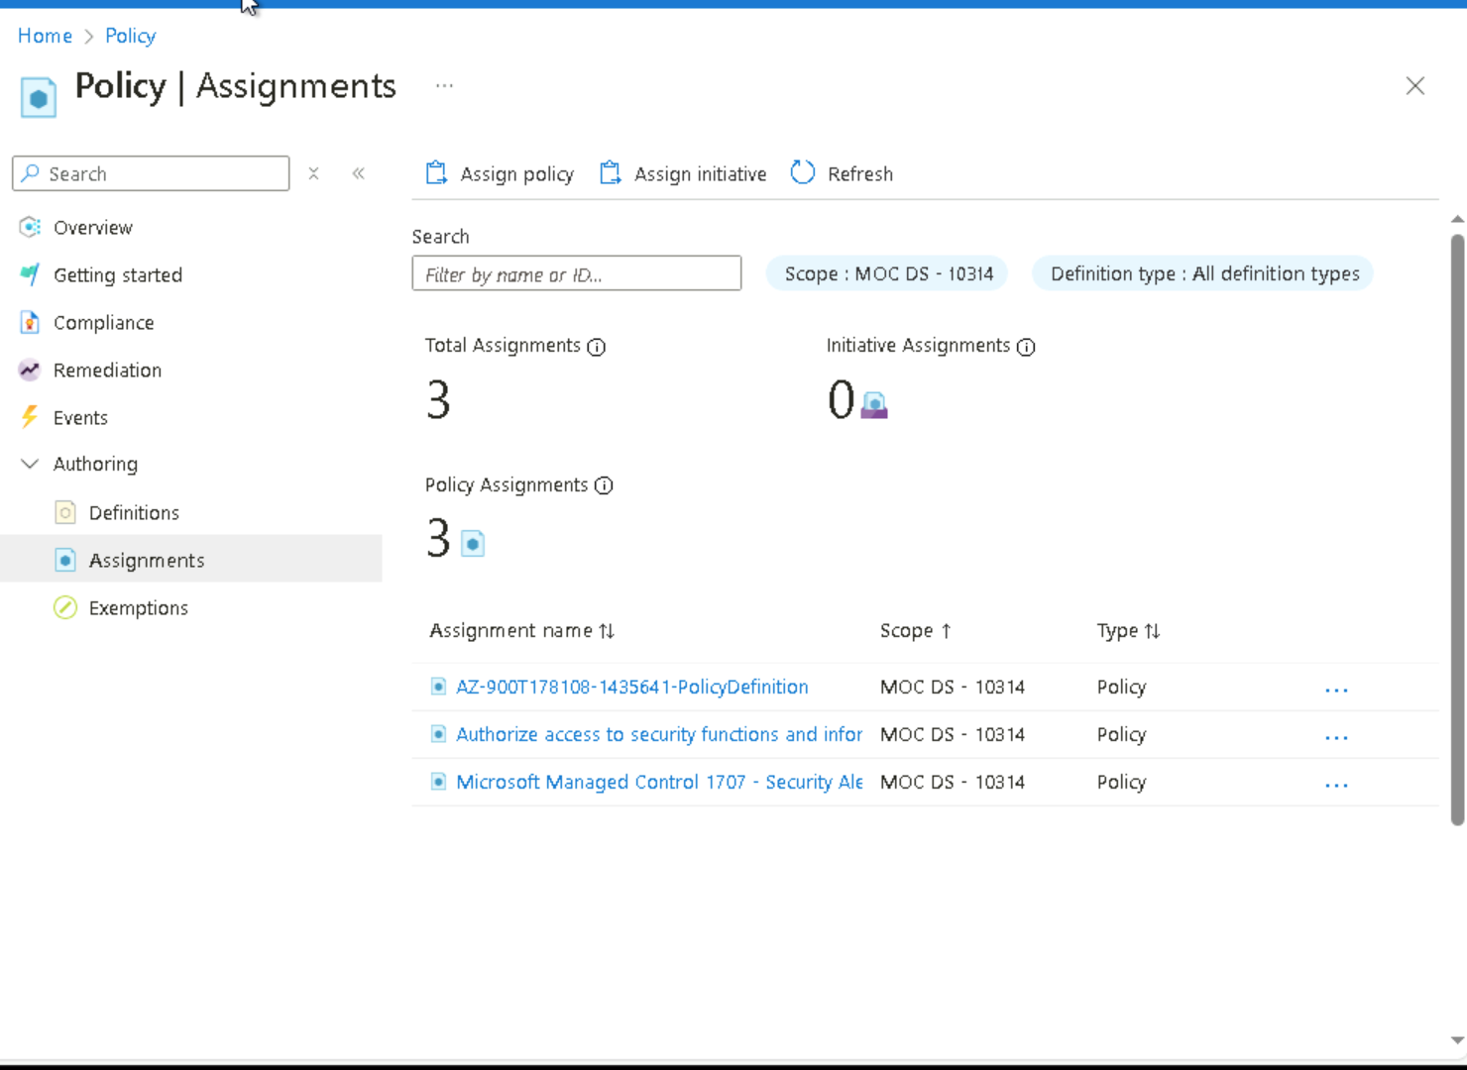
The Allowed locations policy assignment is now listed on the Policy [Assignments] page and it is now in place, enforcing the policy at the scope level specified.

